ASSIGNMENT 1

1. Giving two examples for each, define the following terms:
   1. Food

Food is any substance consumed to provide nutritional support for an organism. It is usually of plant or animal origin, and contains essential nutrients, such as carbohydrates, fats, proteins, vitamins, or minerals. The substance is ingested by an organism and assimilated by the organism's cells to provide energy, maintain life, or stimulate growth.

Historically, humans secured food through two methods: hunting and gathering and agriculture. Today, the majority of the food energy required by the ever increasing population of the world is supplied by the food industry.

* 1. Nutrients

Nutrients are chemical substances that are necessary for life. They are divided into six classes namely; Carbohydrates (CHO), Fats (lipids), Proteins, Vitamins, Minerals, and Water. The nutrient that is not made by the body but is obtained from food diet is called essential nutrients.

These six nutrient classes are chemically divided into two categories: organic and inorganic. Organic nutrients contain hydrogen, oxygen, and carbon (Carbon is an element found in all living things.) and before the body can use them, it must break them down into their smallest components while Inorganic nutrients are already in their simplest forms when the body ingests them, except for water.

* 1. Nutrition

Nutrition is the result of the processes whereby the body takes in and uses food for growth, development, and the maintenance of health. These processes include digestion, absorption, and metabolism. Nutrition helps determine the height and weight of an individual. Nutrition also can affect the body’s ability to resist disease, the length of one’s life, and the state of one’s physical and mental well-being.

1. Distinguish between dispensable and indispensable nutrients

Indispensable nutrients (including amino acids) are those without which life is impossible. Indispensable nutrients that cannot be internally produced, but must be consumed from some external source, are called essential while dispensable nutrients are those that the body can able to synthesis.

For example, **the essential amino acids**, which are also referred to as indispensable, are the ones you must get through the foods you eat because your body can’t make them. Nine out of the 20 amino acids are essential, but adults only need to obtain eight of them: valine, isoleucine, leucine, lysine, methionine, phenylalanine, threonine and tryptophan. The ninth amino acid -- histidine -- is only essential for infants. Your body doesn’t store amino acids, so it needs a regular daily supply of these essential building blocks.

**Nonessential** is a slightly misleading label because these amino acids actually fill essential roles, but since they’re synthesized by your body, they’re not an essential part of your diet. However, you'll still be able to get nonessential amino acids via your diet. The difference is that you don't need to worry about getting enough of these amino acids, since your body will compensate for any gaps in your diet. Alanine, asparagine, arginine, glutamine, tyrosine, cysteine, glycine, proline, serine, aspartate and ornithine are non-esssential amino acids.

Of the 11 nonessential amino acids, eight are called **conditional amino acids**. When you’re sick or under significant stress, your body may not be able to produce enough of these amino acids to meet your needs. The list of conditional amino acids includes arginine, glutamine, tyrosine, cysteine, glycine, proline, serine and ornithine.

1. Suggest a reason why protein deficiency/inadequacy would interfere with the process of digestion.

Protein is one of the most important substances in your body. Your muscles, hair, eyes, organs, and many hormones and enzymes are primarily made out of protein. It also helps to repair and maintain your body tissues. However, not all protein is created equal, and there are things you can do to help your body use it more efficiently.

Protein is a very large nutrient that’s made up of smaller substances called amino acids. There are 20 amino acids, but your body can only make 9 of them. The other 11 are called essential amino acids, and you can only get them through your diet.

High-quality protein sources, such as meat, fish, eggs, and dairy products, contain all nine of the essential amino acids. These are also called whole proteins or complete proteins.

Other protein sources, such as nuts, beans, and seeds, only contain some essential amino acids. However, you can combine some of these protein sources, such as rice and beans, to create a complete protein that contains all nine essential amino acids.

Dietary protein influences mechanical, hormonal and neuroendocrine functions of the GI tract throughout their digestion, absorption and post-absorption processes. The interaction of protein-digested products with enteric nerves and endocrine systems in the GI tract influences their digestion and absorption kinetics and ultimately the metabolic and physiological fate of proteins.

1. Giving specific examples, explain what you understand by the term enzyme specificity.

Enzymes specificity is one of the properties of enzymes that they exhibit relative to the reactions they catalyze. A few enzymes exhibit absolute specificity; that is, they will catalyze only one particular reaction. Other enzymes will be specific for a particular type of chemical bond or functional group. In general, there are four distinct types of specificity:

**Absolute specificity** - the enzyme will catalyze only one reaction.

**Group specificity** - the enzyme will act only on molecules that have specific functional groups, such as amino, phosphate and methyl groups.

**Linkage specificity** - the enzyme will act on a particular type of chemical bond regardless of the rest of the molecular structure.

**Stereo chemical specificity** - the enzyme will act on a particular steric or optical isomer.

Though enzymes exhibit great degrees of specificity, cofactors may serve many apoenzymes. For example, nicotinamide adenine dinucleotide (NAD) is a coenzyme for a great number of dehydrogenase reactions in which it acts as a hydrogen acceptor. Among them are the alcohol dehydrogenase, malate dehydrogenase and lactate dehydrogenase reactions.

1. Explain what you understand by the term antinutrients.

Antinutrients are natural or synthetic compounds that interfere with the absorption of nutrients. Examples include the following;

**Phytic acid** has a strong binding affinity to minerals such as calcium, magnesium, iron, copper, and zinc. This results in precipitation, making the minerals unavailable for absorption in the intestines.

**Protease inhibitors** are substances that inhibit the actions of trypsin, pepsin and other proteases in the gut, preventing the digestion and subsequent absorption of protein.

**Lipase inhibitors** interfere with enzymes, such as human pancreatic lipase, that catalyze the hydrolysis of some lipids, including fats. For example, the anti-obesity drug orlistat causes a percentage of fat to pass through the digestive tract undigested.

**Amylase inhibitors** prevent the action of enzymes that break the glycosidic bonds of starches and other complex carbohydrates, preventing the release of simple sugars and absorption by the body. Amylase inhibitors are present in many types of beans

**Oxalic** acid and **oxalates** are present in many plants and in significant amounts particularly in rhubarb, tea, spinach, parsley and purslane. Oxalates bind to calcium and prevent its absorption in the human body.

**Glucosinolates** prevent the uptake of iodine, affecting the function of the thyroid and thus are considered goitrogens. They are found in plants such as broccoli, brussel sprouts, cabbage, mustard greens, radishes and cauliflower.

1. Explain three functions of bile in the digestion of lipids.

When digesting lipids, bile acts as an emulsifier to break the large fat globules into smaller emulsion droplets. The use of this is that it gives the fat a much larger surface area on which the lipase enzymes (fat digesting) can act on, which in turn makes it a much quicker and efficient process.

Since bile increases the absorption of fats, it is an important part of the absorption of the fat-soluble substances, such as the vitamins A, D, E, and K.

Bile tends to be alkali on average. The pH of common duct bile (7.50 to 8.05) is higher than that of the corresponding gallbladder bile (6.80 to 7.65). Bile in the gallbladder becomes more acidic the longer a person goes without eating, though resting slows this fall in pH. As an alkali, it also has the function of neutralizing excess stomach acid before it enters the duodenum, the first section of the small intestine. Bile salts also act as bactericides, destroying many of the microbes that may be present in the food.

Besides its digestive function, bile serves also as the route of excretion for bilirubin, a byproduct of red blood cells recycled by the liver. Bilirubin derives from hemoglobin by glucuronidation.

1. Explain how proteins differ structurally from carbohydrates and lipids.

[**Proteins**](http://socratic.org/biology/molecular-biology-basics/proteins)**:**

[Proteins](http://socratic.org/biology/molecular-biology-basics/proteins) are large molecules that consist of long chains of amino acids joined together by peptide (CONH) bonds.

The structure of a small protein is:

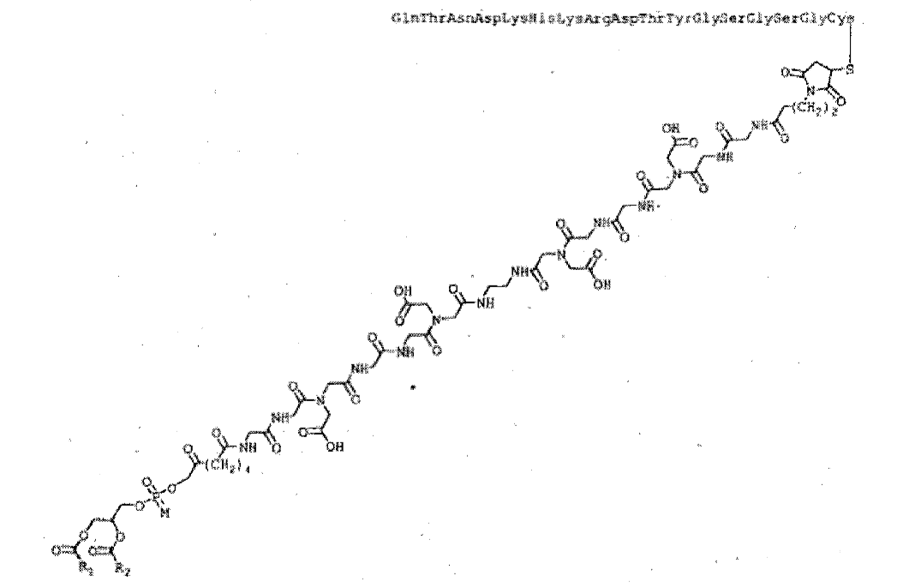 patentimages.storage.googleapis.com

Proteins have polar C=O and N-H groups, so they are able to form hydrogen bonds with other molecules and with each other.

[**Carbohydrates**](http://socratic.org/biology/molecular-biology-basics/carbohydrates):

Carbohydrates have many polar OH groups.

A typical carbohydrate is starch, which is consists of many glucose units (C6H12O6) joined together.

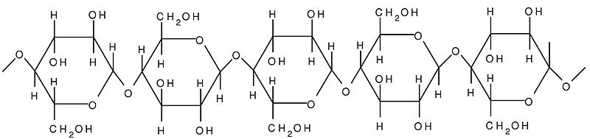upload.wikimedia.org

Most carbohydrates are **hydrophilic** and soluble in water because of their polar OHgroups.

[**Lipids**](http://socratic.org/biology/molecular-biology-basics/lipids)**:**

Lipids are **hydrophobic** and insoluble in water.

They have varied structures, but all have a polar "head" and a large nonpolar "tail"".

Fats and oils are typical lipids.

The structure of a typical fat is

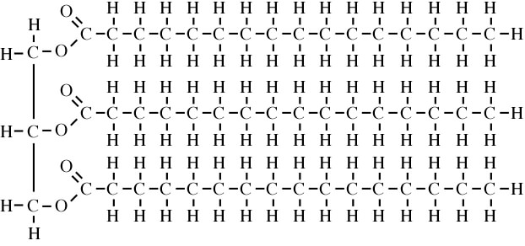www.indiana.edu

The molecule is mostly nonpolar hydrocarbon with some polar C=O groups at one

References:

<https://en.wikipedia.org/wiki/Food>

Diploma in Nutrition manual (module 1, page 3-4)

Diploma in Nutrition manual (module1, page 5).

<https://english.stackexchange.com/questions/166081/whats-the-difference-between-indispensable-amino-acid-and-essential-amino-ac>

<https://healthyeating.sfgate.com/difference-between-essential-non-essential-amino-acids-9687.html>

<https://www.ncbi.nlm.nih.gov/pmc/articles/PMC3257691/>

<https://www.healthline.com/health/protein-digestion>

<http://www.worthington-biochem.com/introbiochem/specificity.html>

<https://en.wikipedia.org/wiki/Antinutrient>

<https://socratic.org/questions/what-is-the-role-of-bile-in-digestion-of-fats>

<https://en.wikipedia.org/wiki/Bile>

<https://socratic.org/questions/how-do-proteins-differ-from-carbohydrates-and-lipids>